**Experiment No:** 02

**Title:** Configure multiple network of each three router.

**Problem Statement:**

To learns how to configure multiple router for packet transmission in Cisco packet tracer simulation software.

**Objective:**

Multiple devices are connected with switches and the switches are connected with different routers. The routers are connected with each other. We will build a network between the devices via switches and devices so that we can send massages or data using that network.

**Hypothesis:**

At first we made a proper connection by setting up IP address of each PC and provide a Next hope IP address for packet transmission between two or more LAN.

**Materials:**

Cisco Packet Tracer Software

**Devices:**

1. 3 Router
2. 3 Switches
3. 6 PC
4. Copper straight cable
5. Copper Cross-Over cable
6. Serial DCE

**Procedure:**

* Design the connection using Cisco Packet Tracer Software like figure 1.

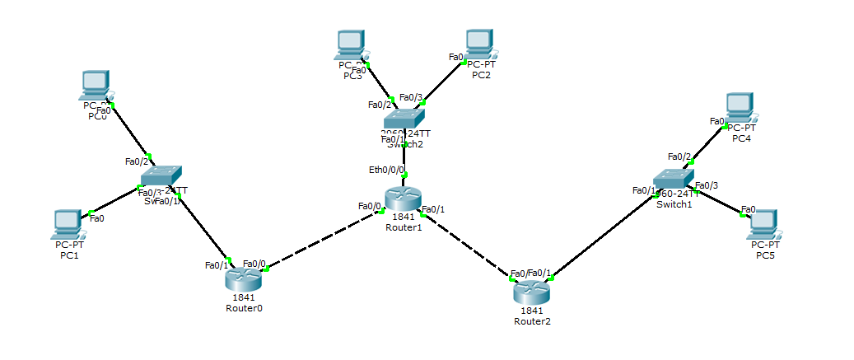

Figure: 01

* Connect 3 routers (router0, router1 and router2).
* Each router connect with a switch

-Router0 connect with switch1

-Router1 connect with switch2

-Router2 connect with switch3

* And then each switch connect with 2 pc

-PC0 and PC1 with switch1

-PC2 and PC3 with switch2

-PC4 and PC5 with switch3

* **IP Configuration:**

**PC0: PC1:**

IP: 192.168.1.1 IP: 192.168.1.2

Subnet mask: 255.255.255.0 Subnet mask: 255.255.255.0

Gateway: 192.168.1.254 Gateway: 192.168.1.254

**PC2: PC3:**

IP: 192.168.3.2 IP: 192.168.3.1

Subnet mask: 255.255.255.0 Subnet mask: 255.255.255.0

Gateway: 192.168.3.254 Gateway: 192.168.3.254

**PC4: PC5:**

IP: 192.168.5.1 IP: 192.168.5.2

Subnet mask: 255.255.255.0 Subnet mask: 255.255.255.0

Gateway: 192.168.5.254 Gateway: 192.168.5.254

* **Configure Router:**

**-Router0**

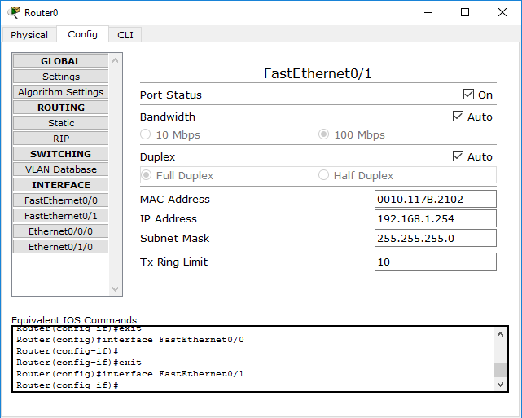

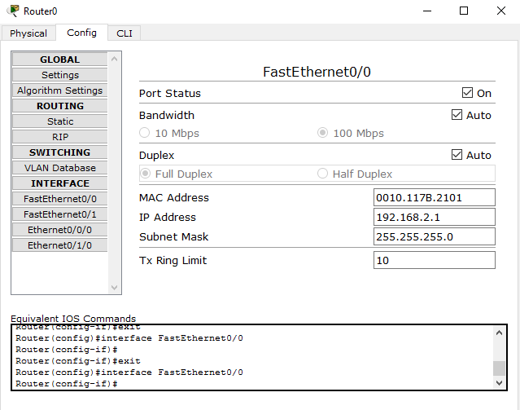

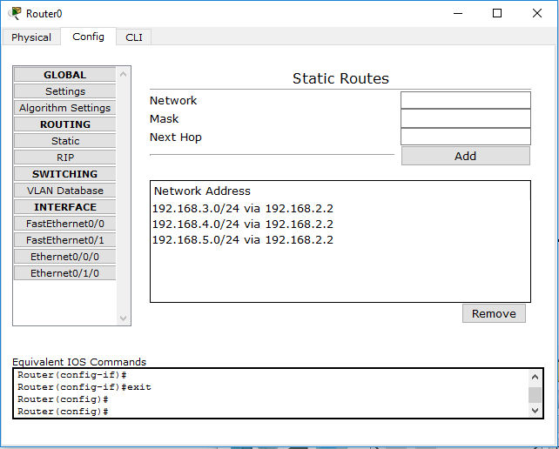

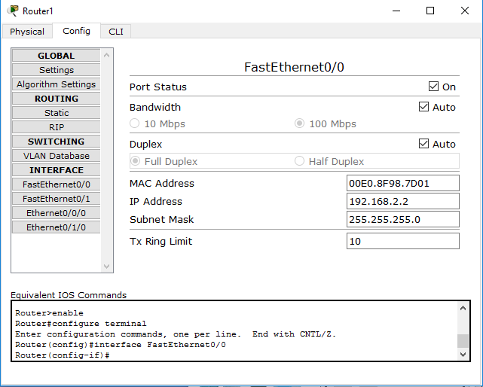 **-Router1**

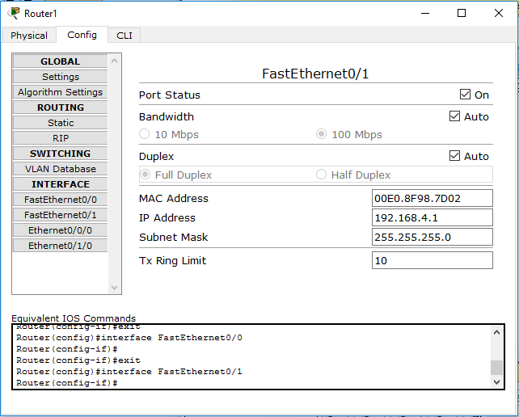

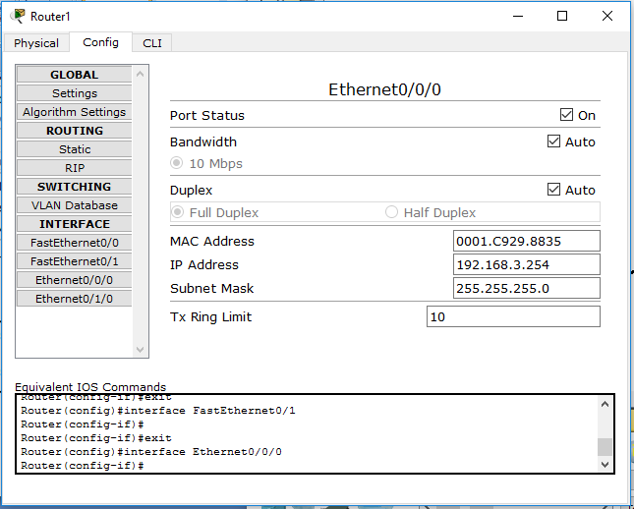

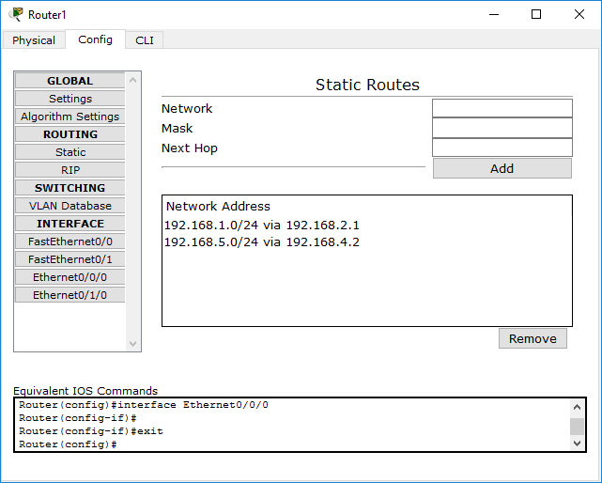

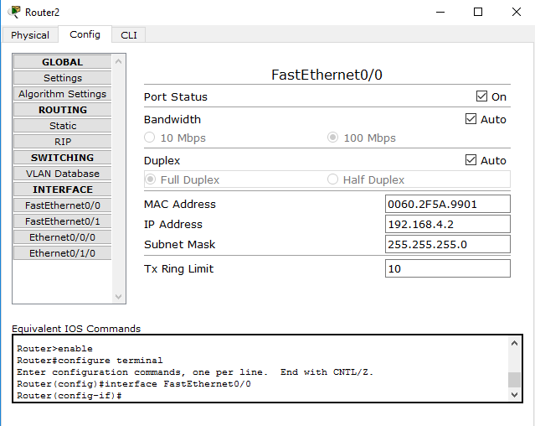 **-Router2**

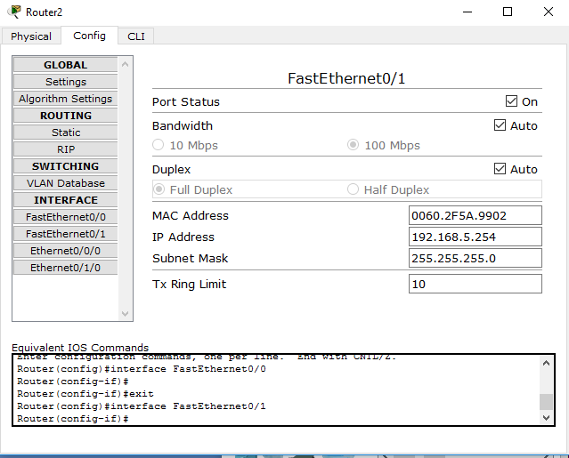

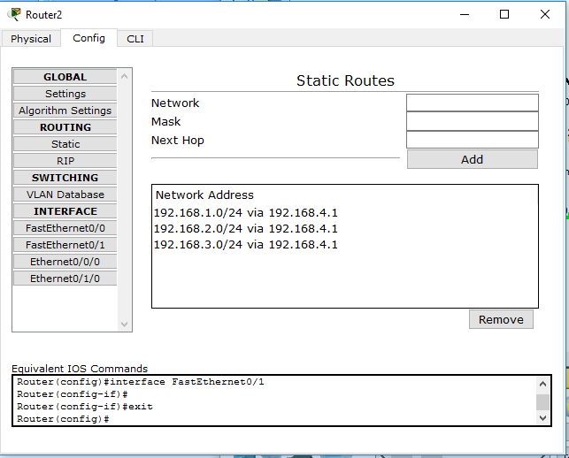

* Here all the PCs are connected to the different networks and routers connect them. All the configurations are properly done that’s why the connections are green.
* Select message option and select the sender and receiver
* If the connections are properly made and networks are properly set then we can send packet from one network to another.

**Discussions:**

* We must check all the connections and IP addresses to ensure successful data transfer.
* If the number of computer increases then the communication will become more complex.
* Switching speed is an important factor here.